DRONE DELIVERY MANAGEMENT SYSTEM

EXPERIMENT – 1

Date:

AIM
To create the Drone Delivery Management System database using DDL commands such as CREATE, ALTER, DROP, RENAME, and TRUNCATE.

PROCEDURE
- Open MySQL Command Line.
- Create the DroneDelivery database.
- Select the database.
- Create the required tables.
- Modify tables using ALTER.
- Rename a table.
- Truncate the renamed table.
- Drop the renamed table.
- Verify the remaining tables.

Query 1
DROP DATABASE IF EXISTS DroneDelivery;

CREATE DATABASE DroneDelivery;

USE DroneDelivery;

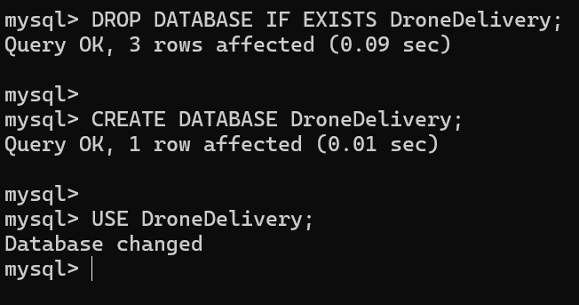

Query 2
CREATE TABLE Customers
(
CustomerID INT,
CustomerName VARCHAR(100),
Phone VARCHAR(15),
Address VARCHAR(200)

);
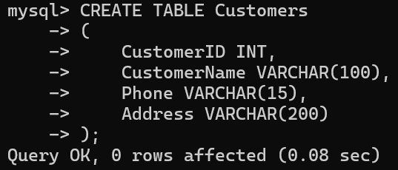

Query 3
CREATE TABLE Drones
(
DroneID INT,
DroneModel VARCHAR(100),
PayloadCapacity DECIMAL(5,2),
DroneStatus VARCHAR(30)
);
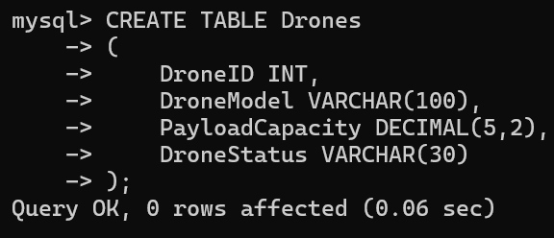

Query 4
CREATE TABLE Deliveries
(
DeliveryID INT,
CustomerID INT,
DroneID INT,
Destination VARCHAR(200),
DeliveryDate DATE,
DeliveryStatus VARCHAR(30)
);
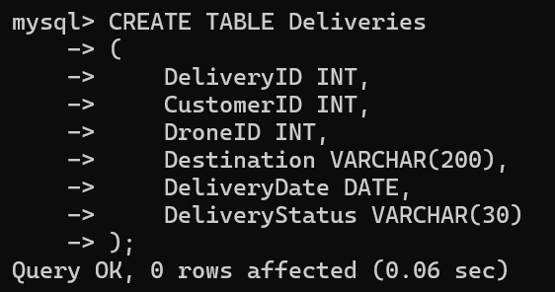

Query 5
CREATE TABLE Operators
( OperatorID INT,
OperatorName VARCHAR(100),
Experience INT
);
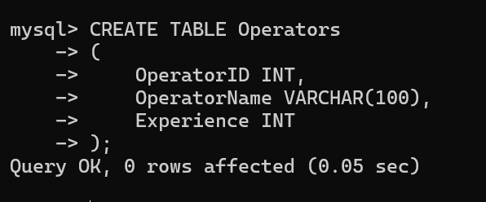

Query 6
ALTER TABLE Customers
ADD Email VARCHAR(100);
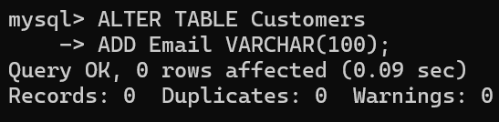

Query 7
ALTER TABLE Drones
ADD BatteryHealth INT;
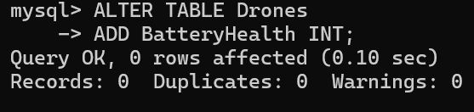

Query 8
RENAME TABLE Operators TO DroneOperators;
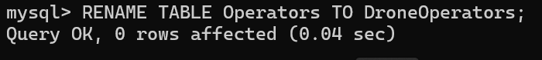
Query 9
TRUNCATE TABLE DroneOperators;
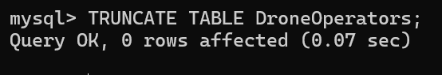
Query 10
DROP TABLE DroneOperators;
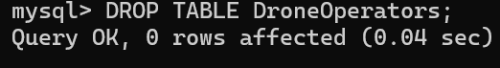
Query 11
SHOW TABLES;
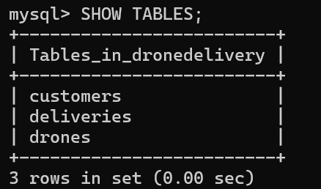

RESULT
Thus, the Drone Delivery Management System database and tables were successfully created and modified using DDL commands (CREATE, ALTER, RENAME, TRUNCATE, and DROP).

